<https://www.youtube.com/watch?v=yOWncIyx864&list=PLblh5JKOoLUICTaGLRoHQDuF_7q2GfuJF&index=66>



Today we're going to talk about back propagation details part 1.

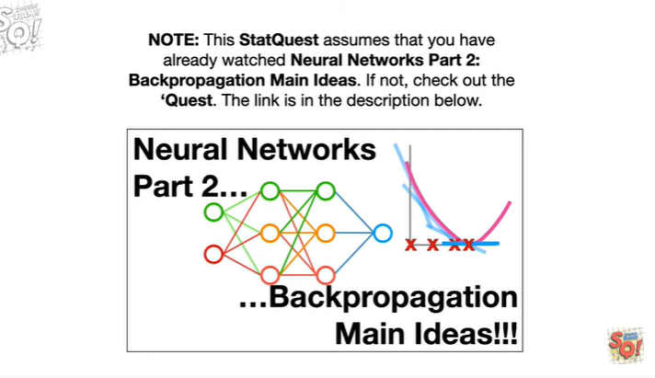

Note : this stat quest assumes that you have already watched neural networks part 2 back propagation main ideas.

If not, check out the quest.

The link is in the description below.

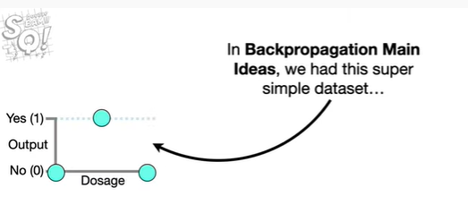

In back propagation main ideas we had this super simple data set

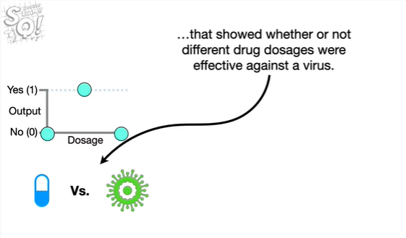

that showed whether or not different drug dosages were effective against a virus.

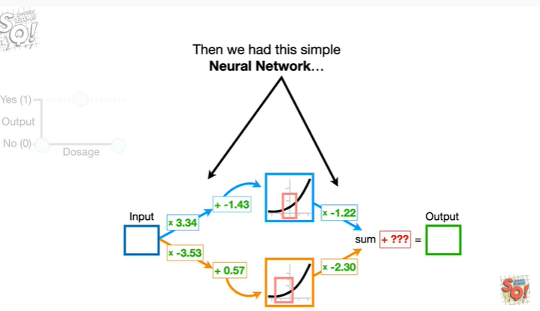

Then we had this simple neural network

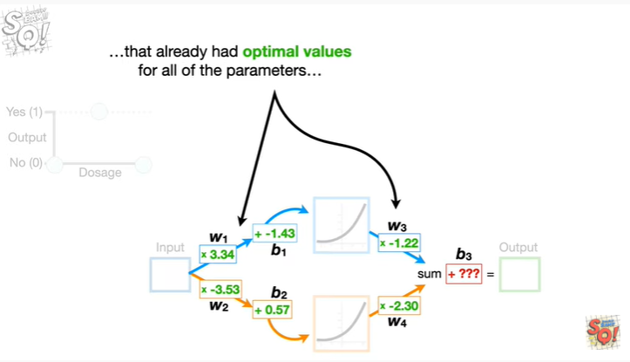

that already had optimal values for all of the parameters

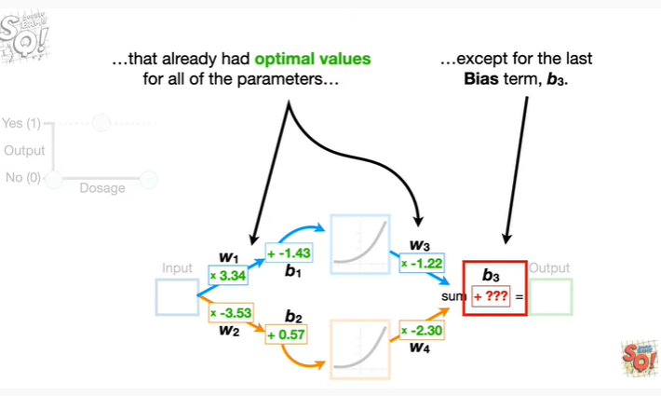

except for the last bias term b sub 3.

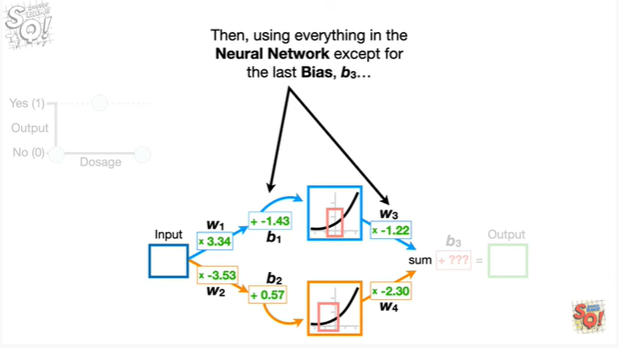

Then, using everything in the neural network except for the last bias, b sub 3

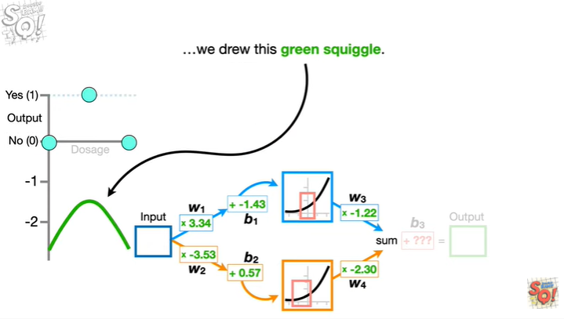

we drew this green squiggle.

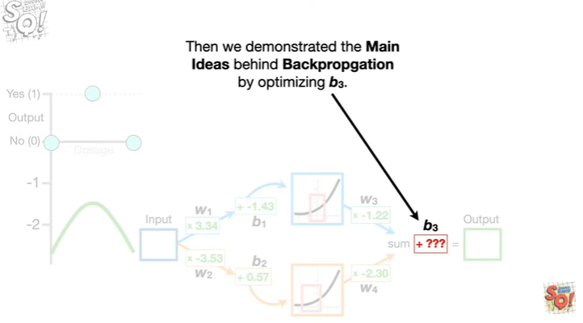

Then we demonstrated the main ideas behind back propagation by optimizing b sub 3.

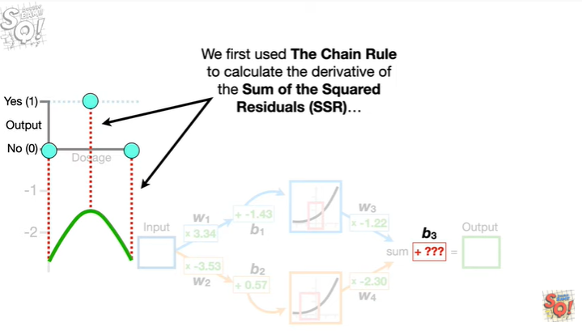

We first used the chain rule to calculate the derivative of the sum of the squared residuals

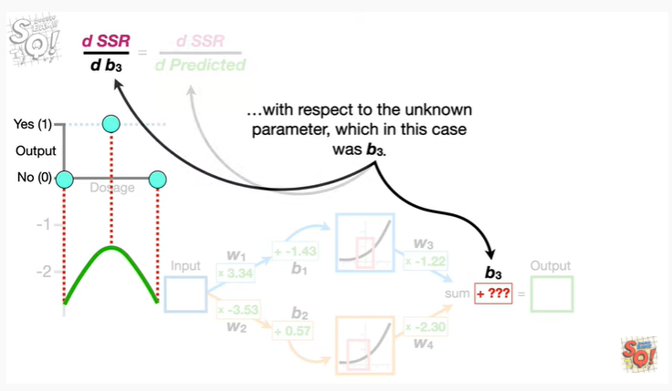

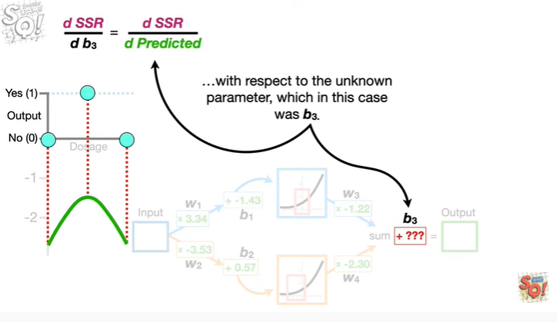

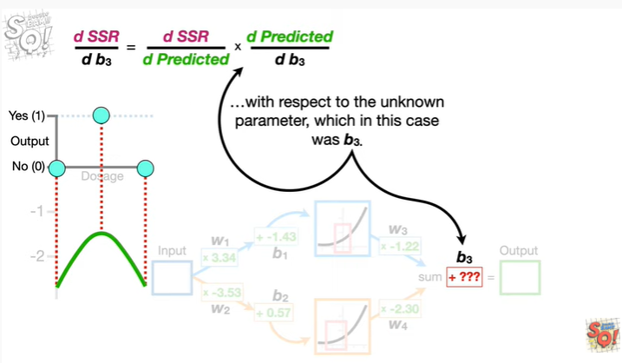

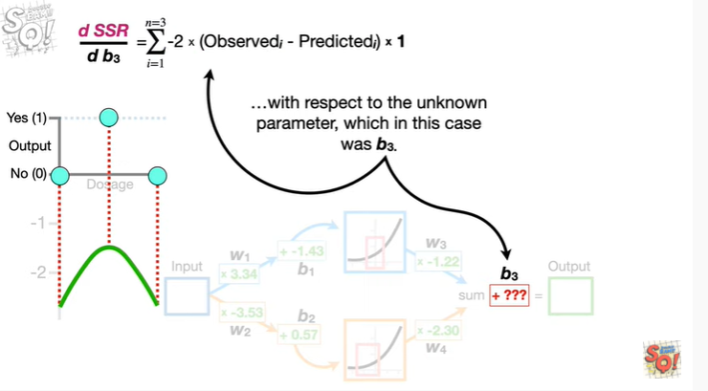

with respect to the unknown parameter which in this case was b sub 3.

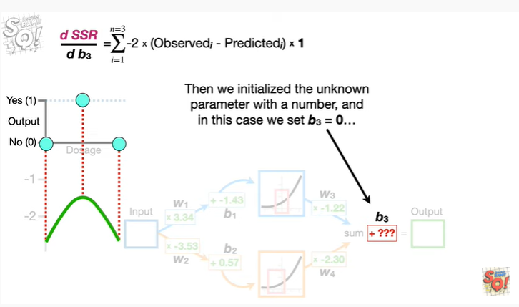

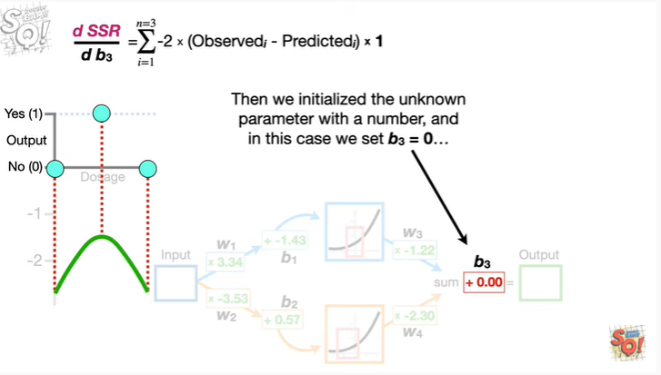

Then we initialized the unknown parameter with a number and in this case we set b sub 3 equal to 0.

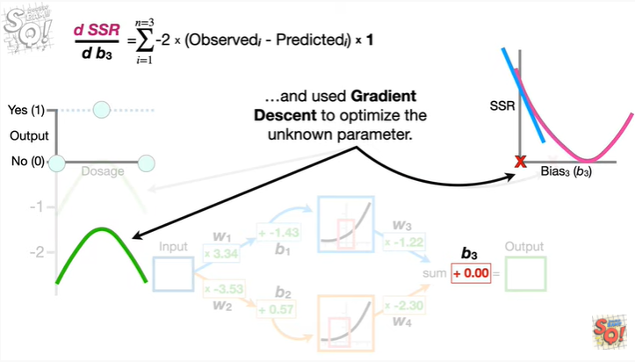

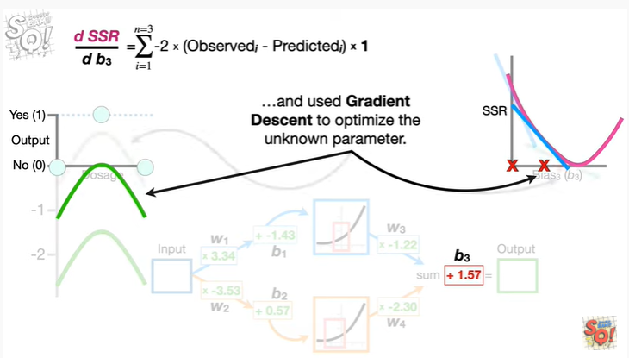

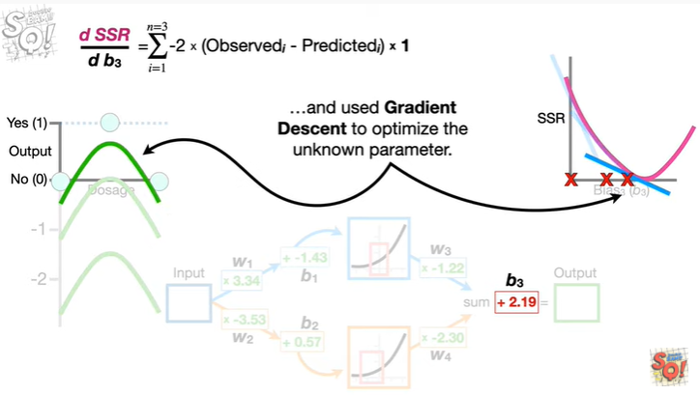

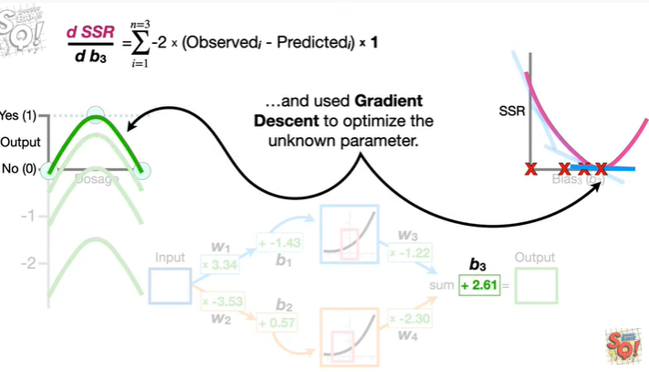

and used gradient descent to optimize the unknown parameter.

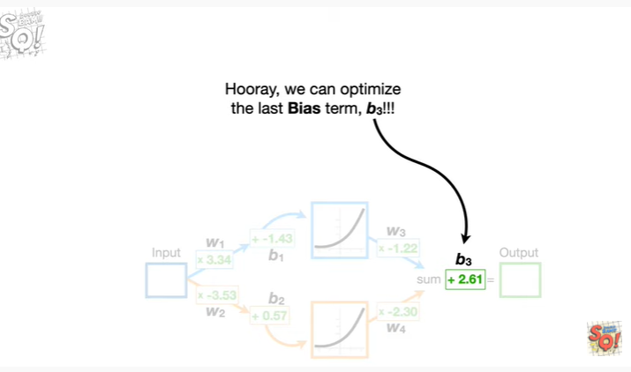

Hooray ,we can optimize the last bias term, b sub 3 !!!

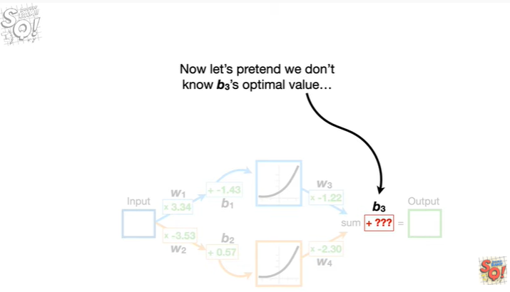

Now let's pretend we don't know b sub 3's optimal value

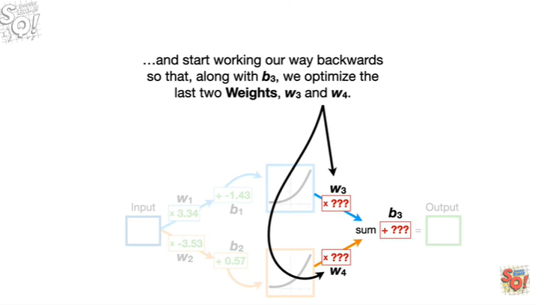

and start working our way backwards so that along with b sub 3, we optimize the last two weights, w sub 3 and w sub 4.

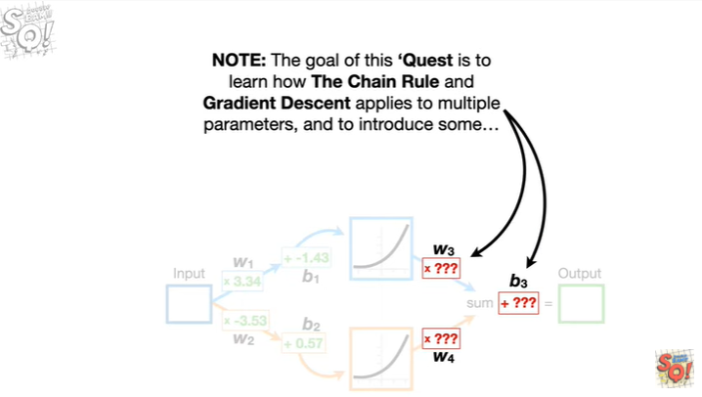

Note : the goal of this quest is to learn how the chain rule and gradient ascent applies to multiple parameters, and to introduce some

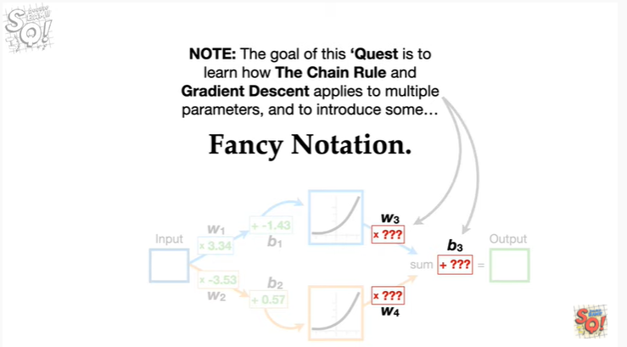

fancy notation.

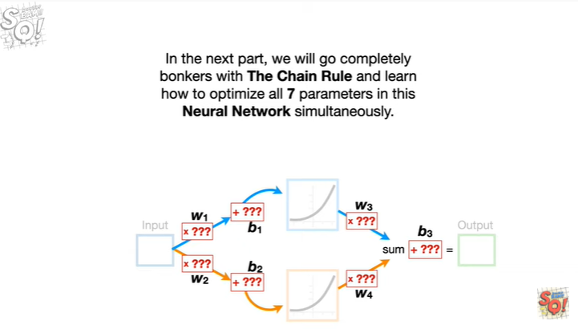

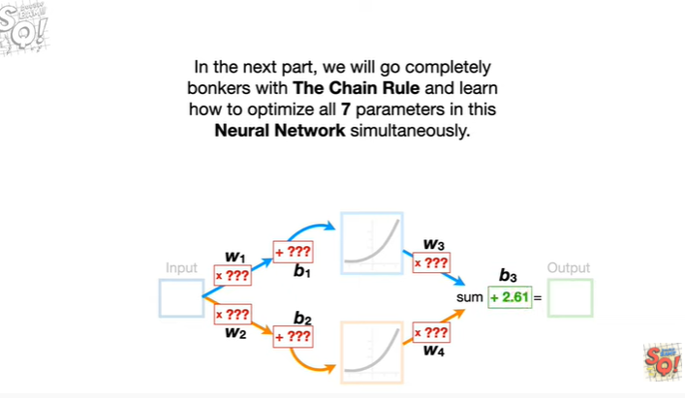

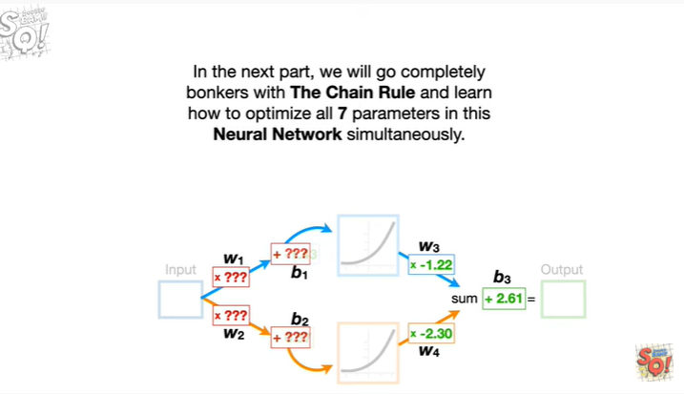

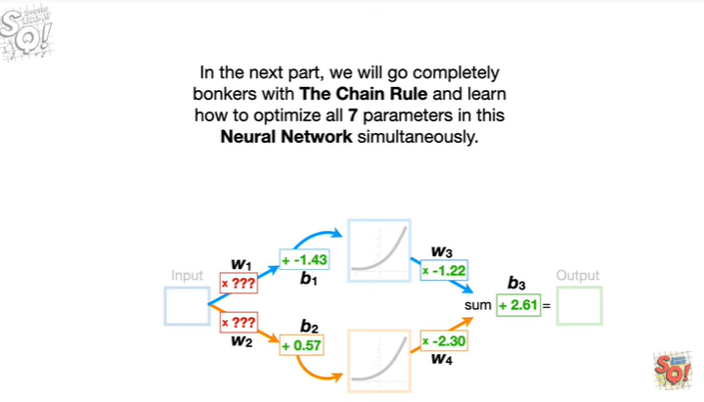

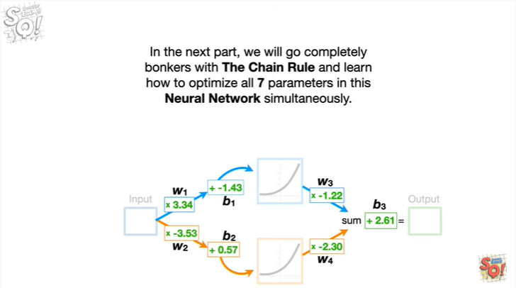

In the next part, we'll go completely bonkers with the chain rule and learn how to optimize all seven parameters in this neural network simultaneously.

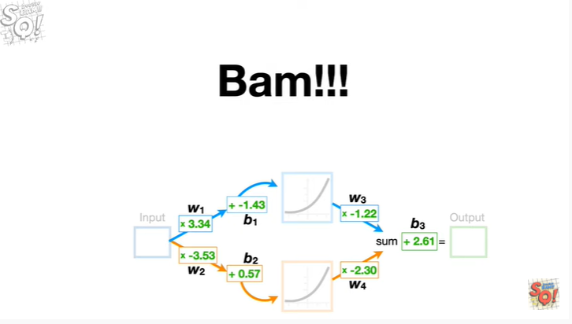

Bam !!!

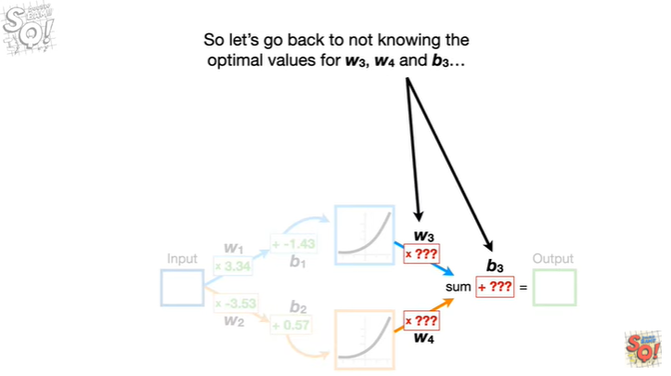

So let's go back to not knowing the optimal values for w sub 3 w sub 4 and b sub 3

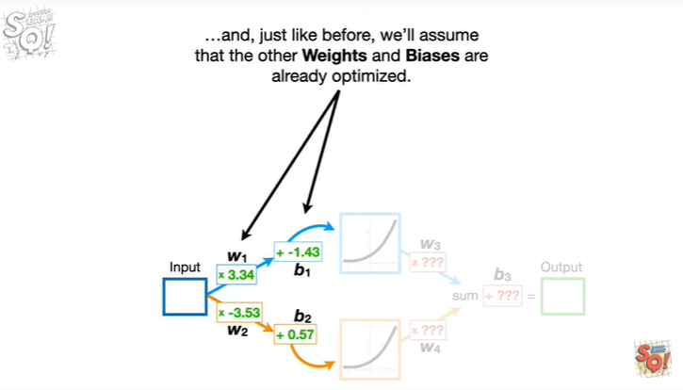

And, just like before, we'll assume that the other weights and biases are already optimized.

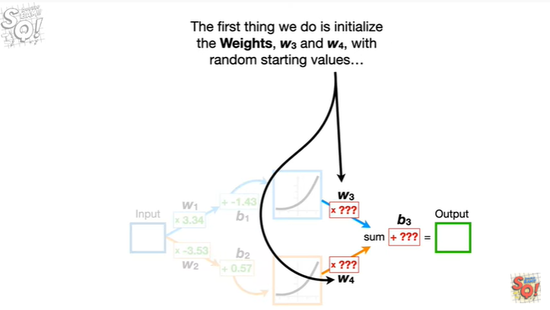

The first thing we do is initialize the weights, w sub 3 and w sub 4, with random starting values

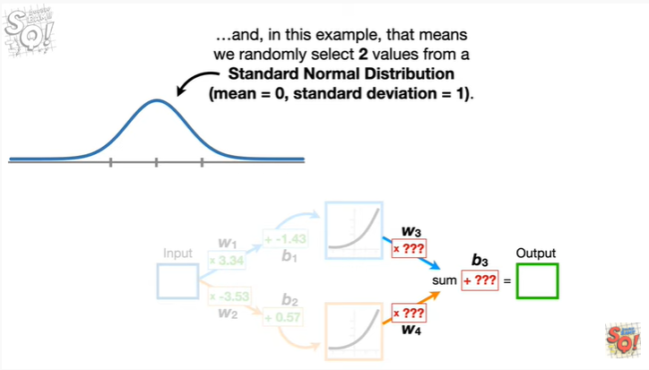

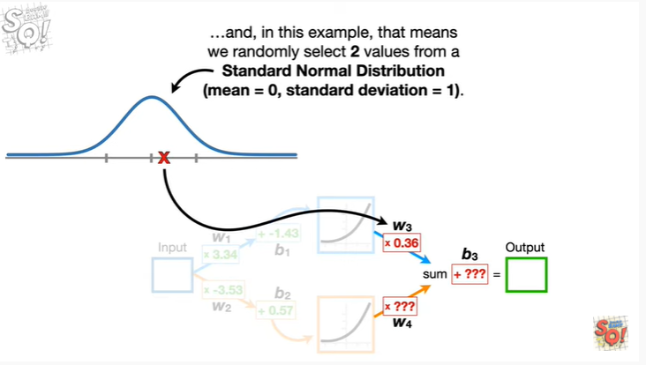

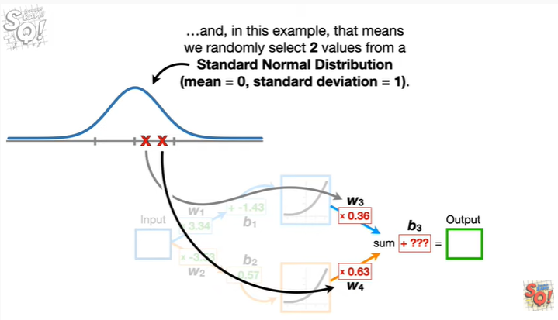

And, in this example, that means we randomly select two values from a standard normal distribution.

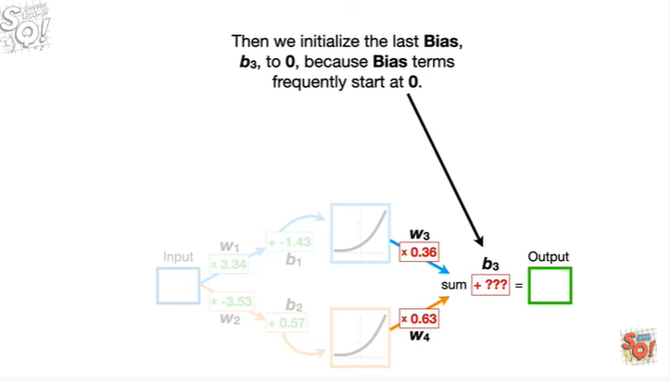

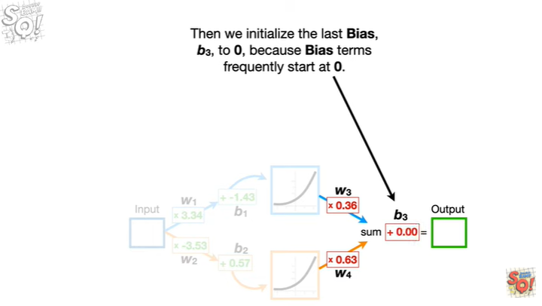

Then we initialize the last bias b sub 3, to zero, because bias terms frequently start at zero.

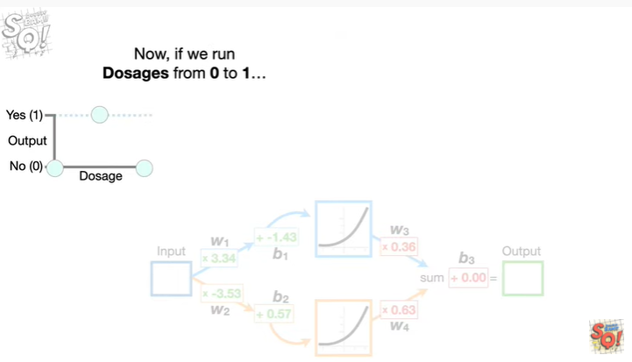

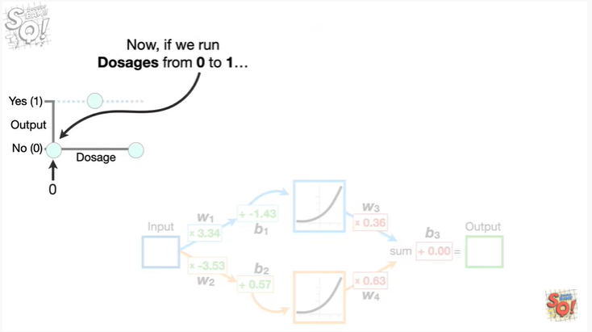

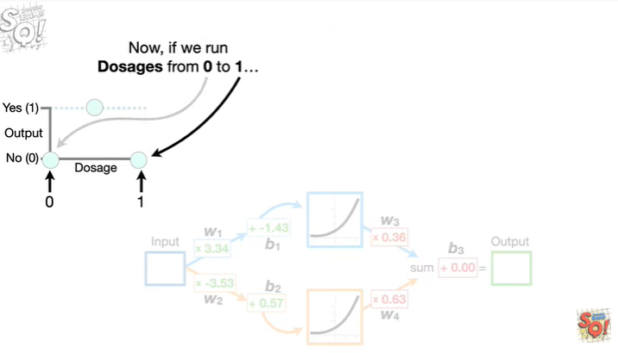

Now, if we run dosages from 0 to 1

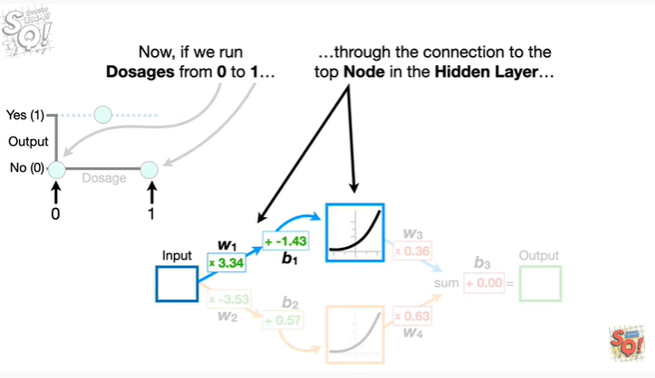

through the connection to the top node in the hidden layer

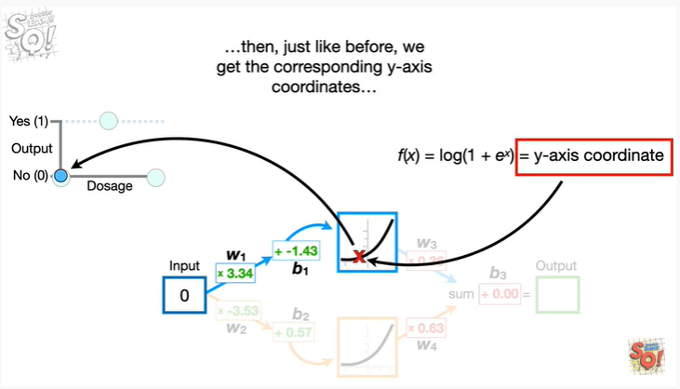

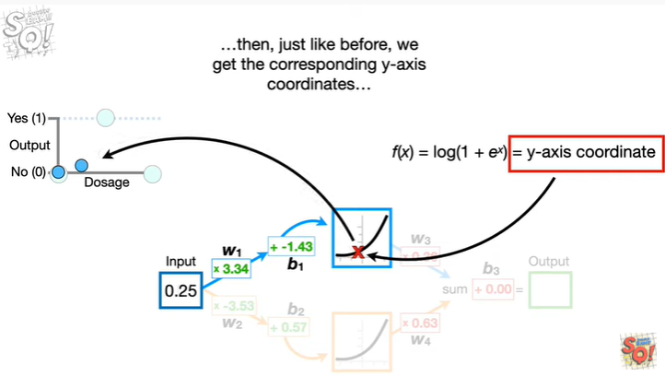

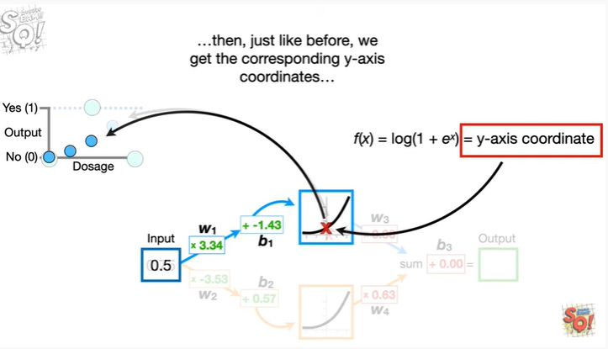

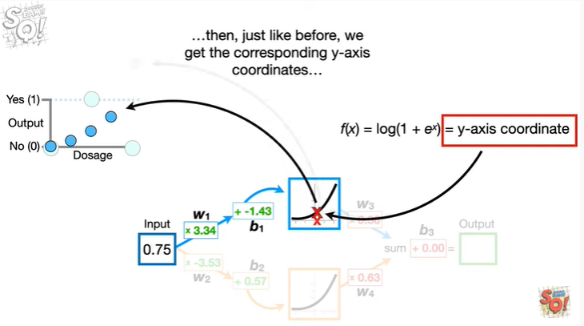

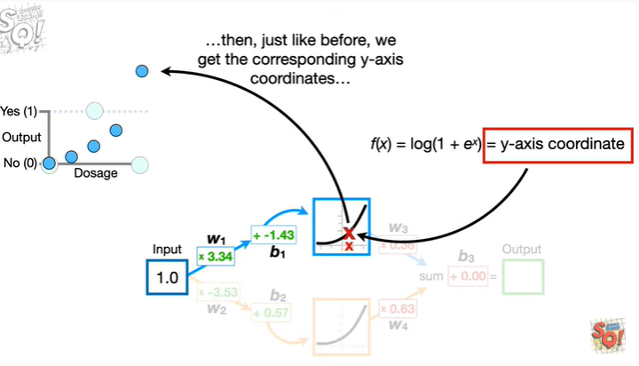

then just like before we get the corresponding y-axis coordinates

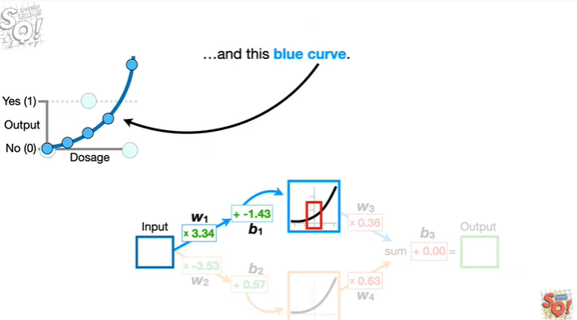

and this blue curve.

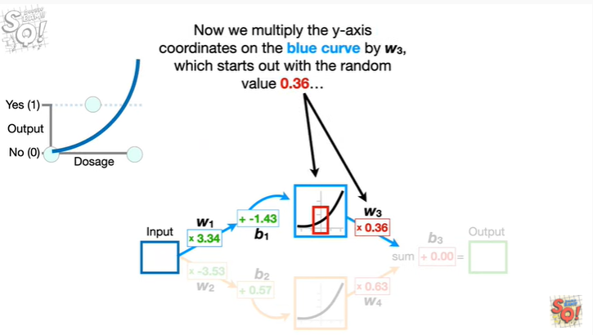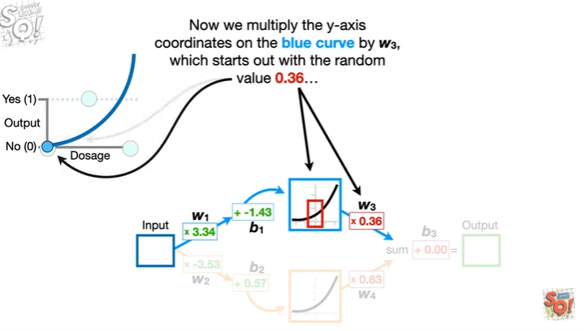

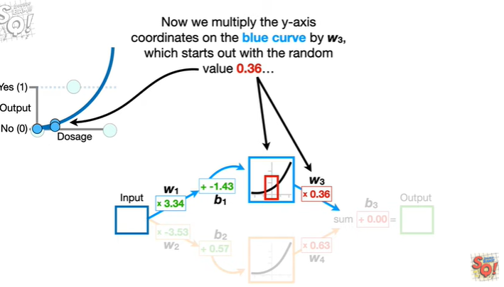

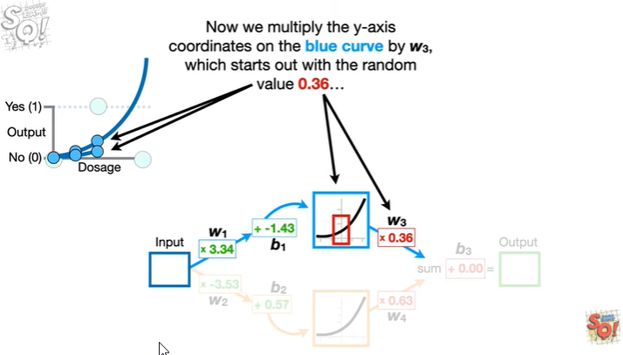

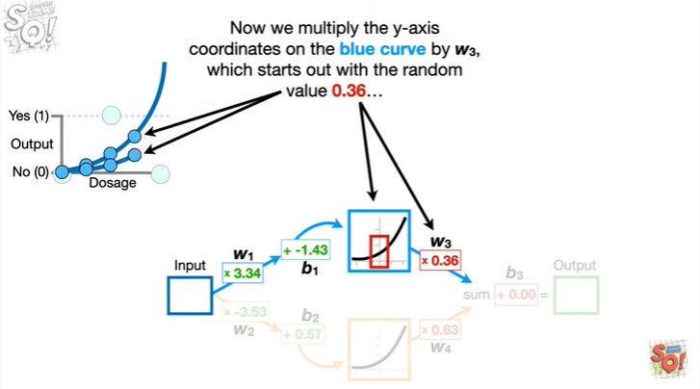

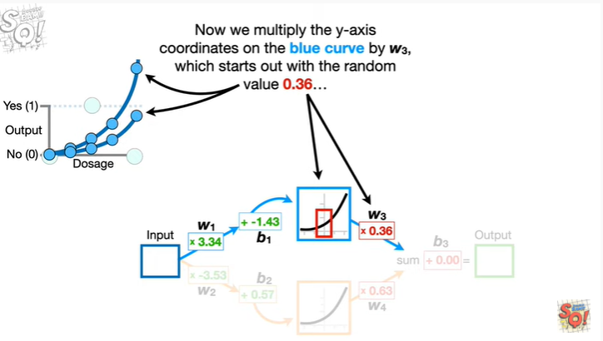

Now we multiply the y-axis coordinates on the blue curve by w sub 3, which starts out with the random value 0.36

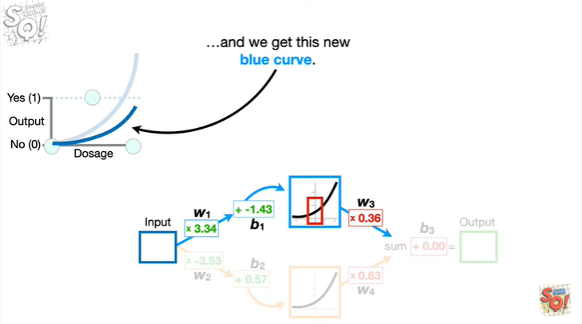

and we get this new blue curve.

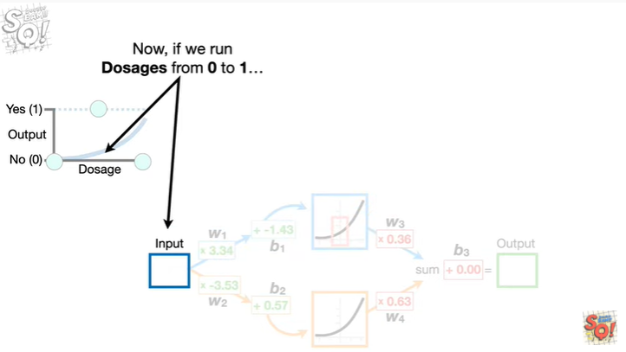

Now, if we run dosages from 0 to 1

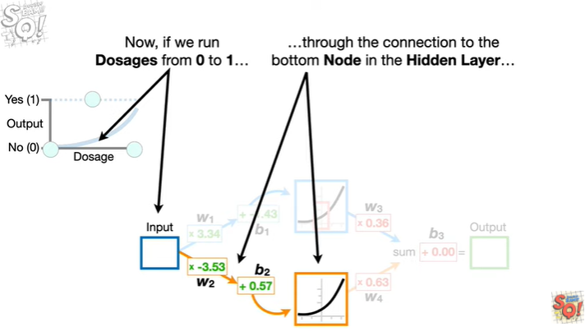

through the connection to the bottom node in the hidden layer

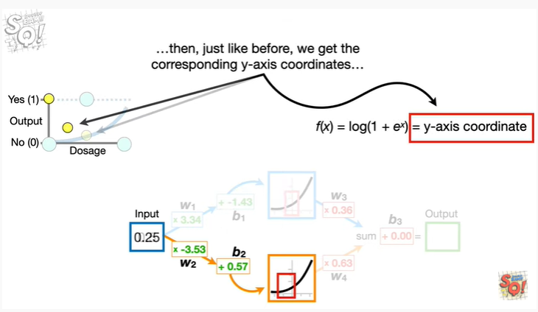

Then, just like before, we get the corresponding y-axis coordinates

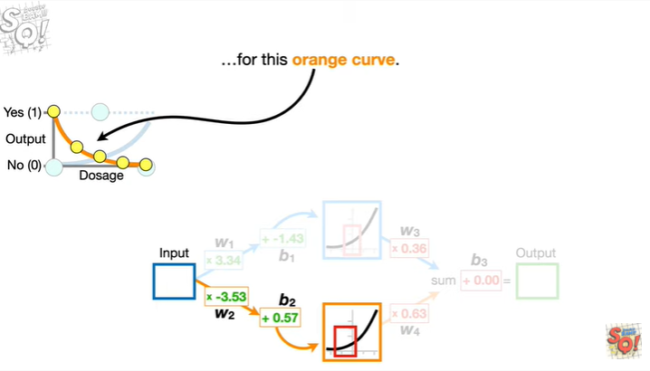

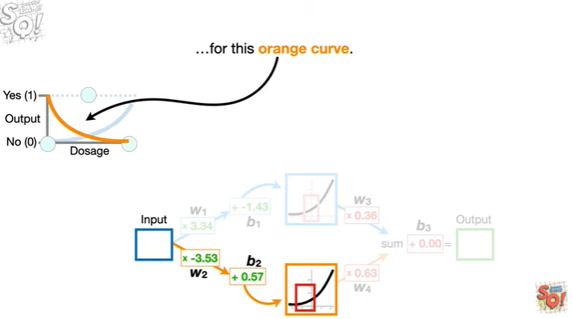

for this orange curve.

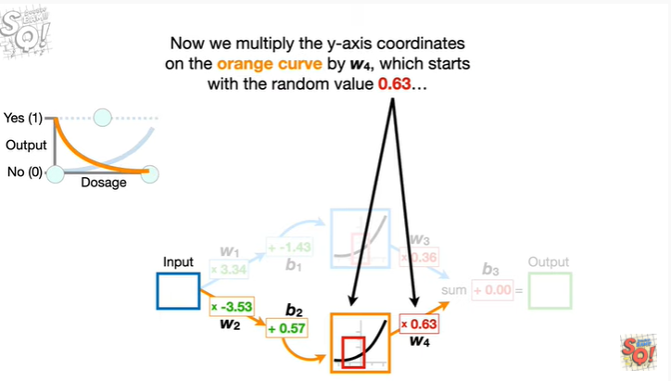

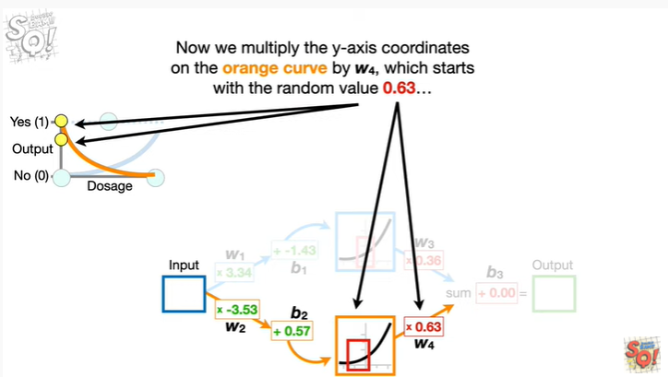

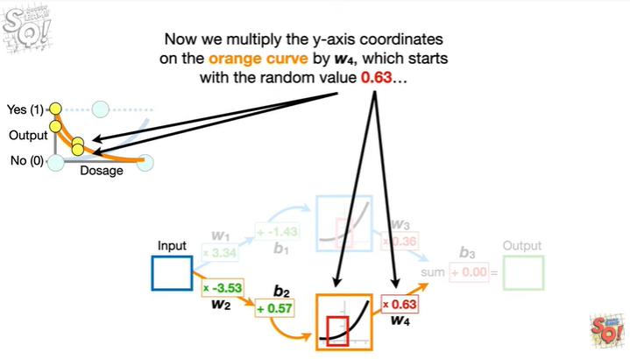

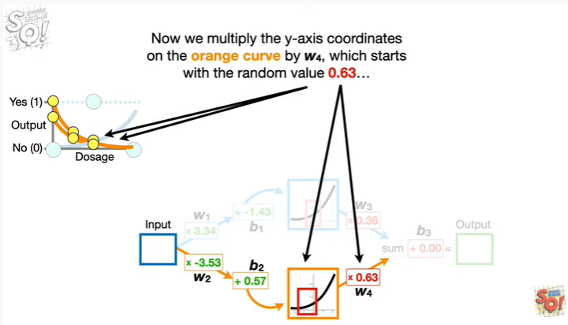

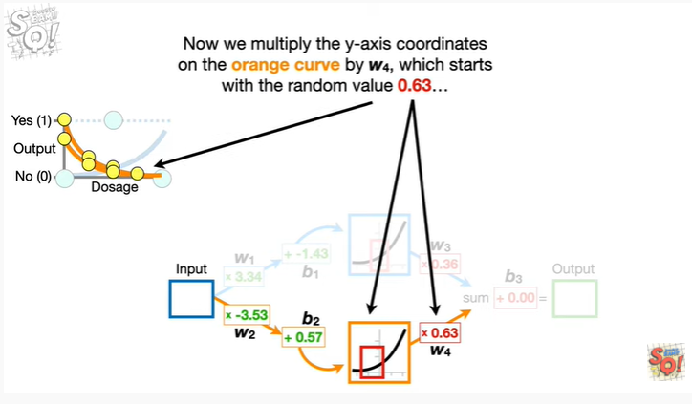

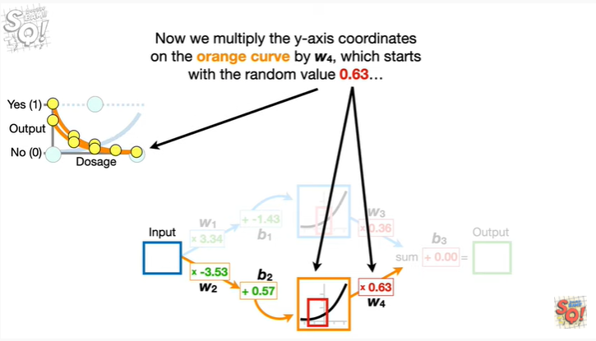

Now we multiply the y-axis coordinates on the orange curve by w sub 4 which starts with the random value 0.63

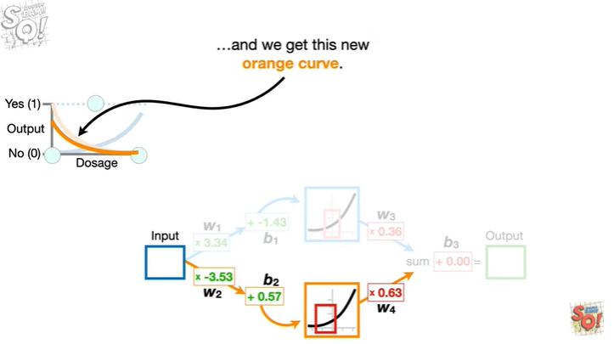

and we get this new orange curve.

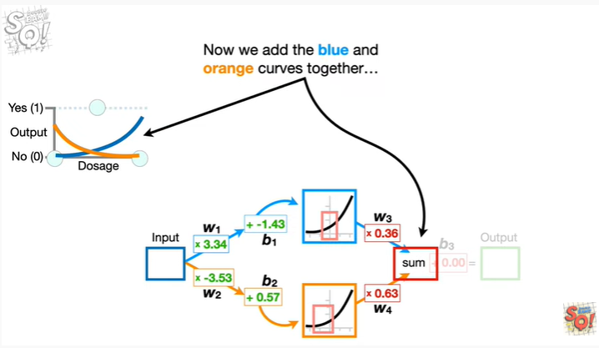

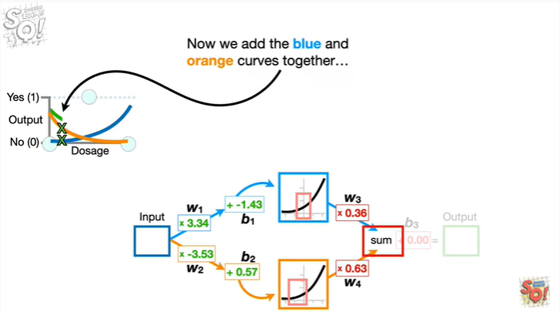

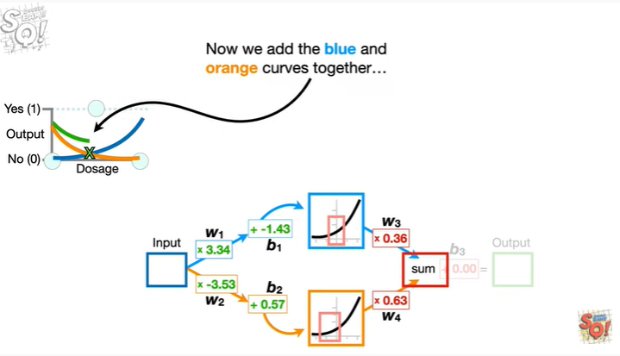

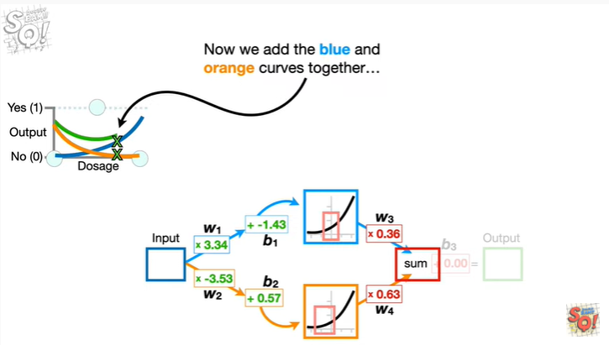

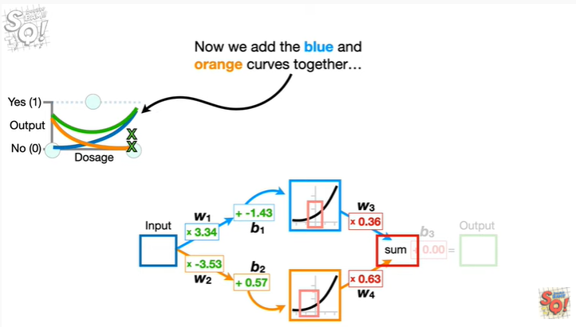

Now we add the blue and orange curves together

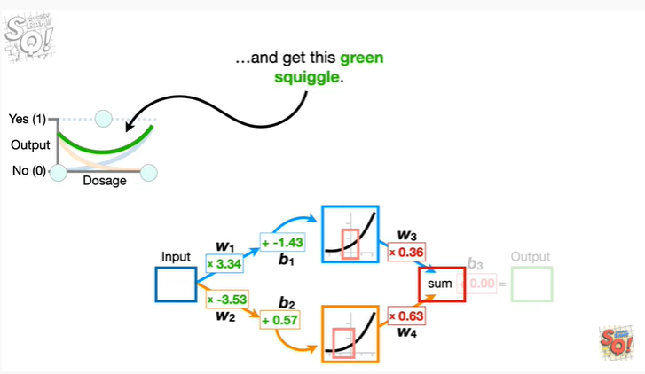

and get this green squiggle.

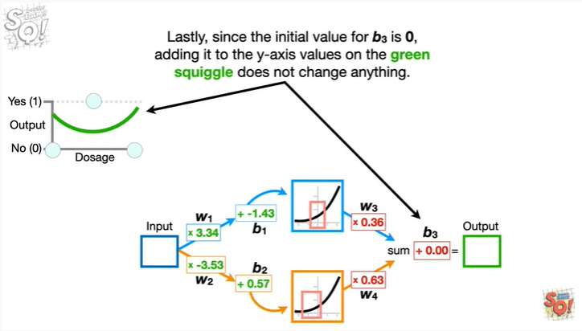

Lastly, since the initial value for b sub 3 is 0, adding it to the y axis values on the green squiggle does not change anything.

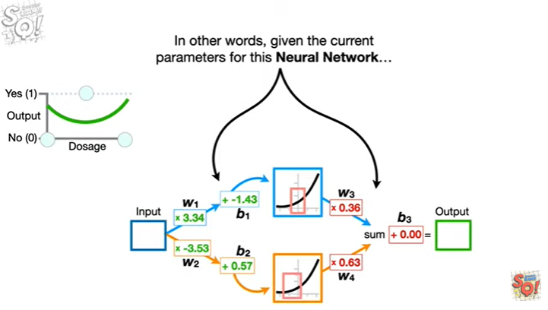

In other words, given the current parameters for this neural network

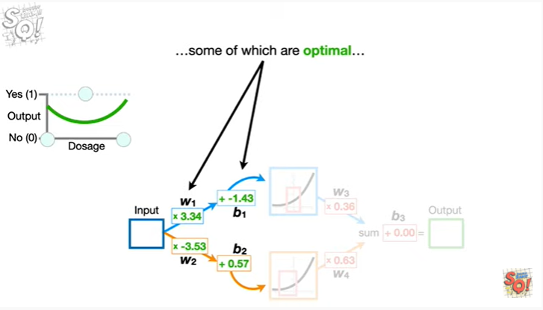

some of which are optimal

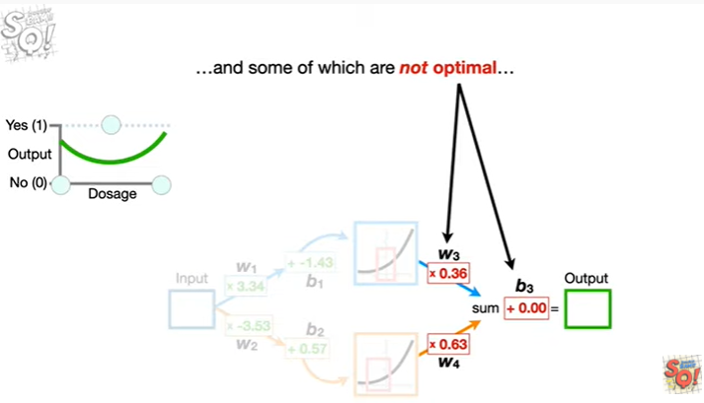

and some of which are not optimal

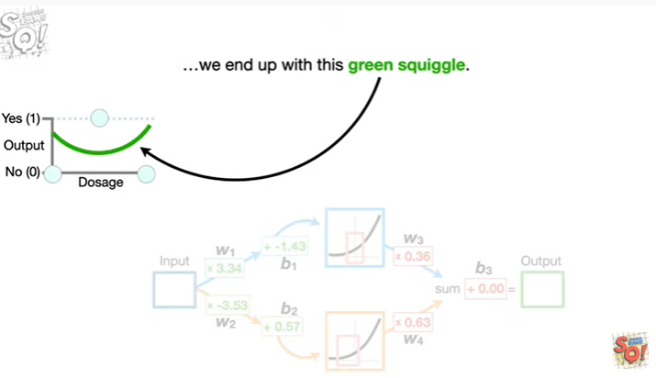

we end up with this green squiggle.

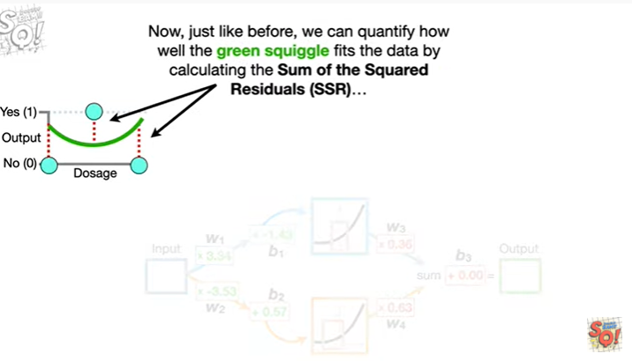

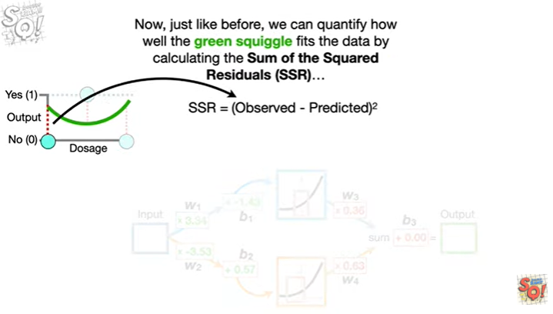

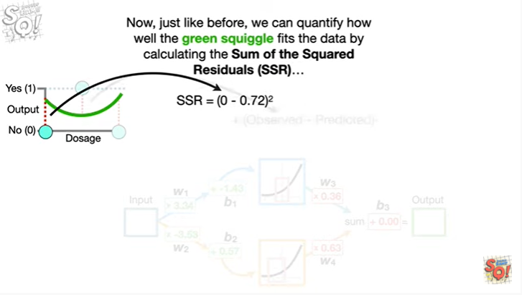

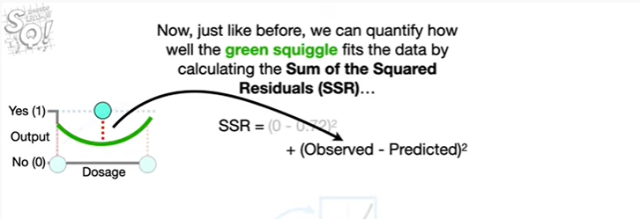

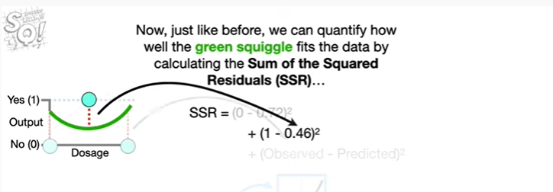

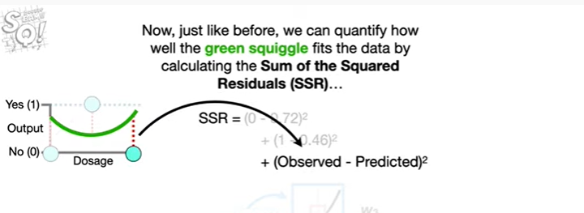

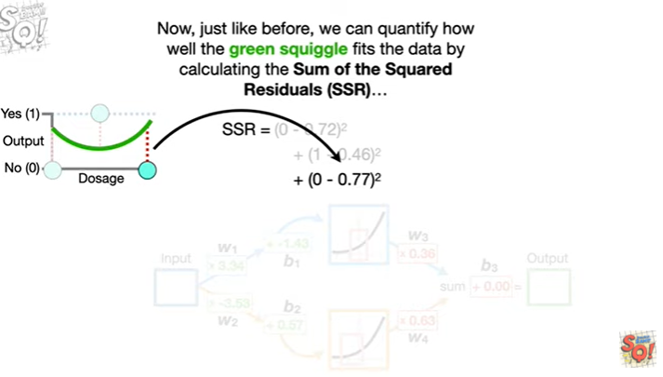

Now, just like before, we can quantify how well the green squiggle fits the data by calculating the sum of the squared residuals

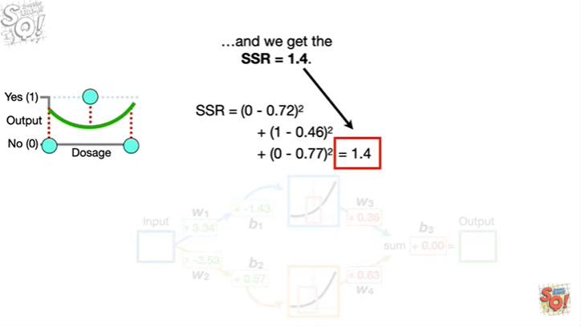

and we get the sum of the squared residuals equals 1.4.

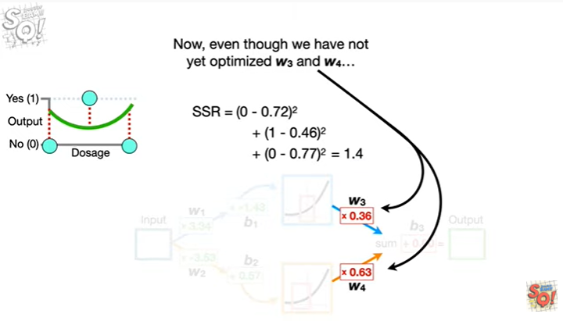

Now, even though we have not yet optimized w sub 3 and w sub 4

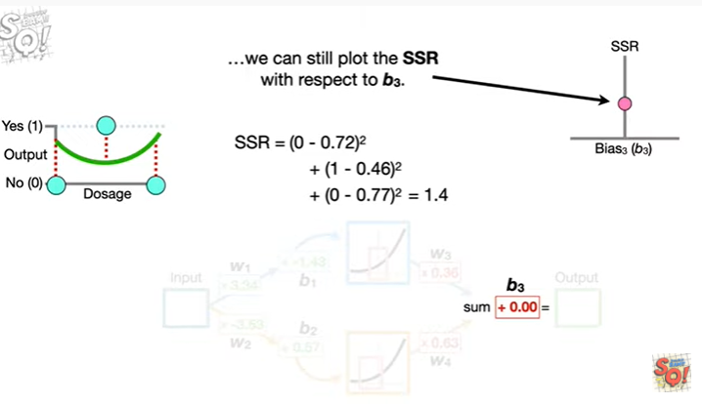

we can still plot the sum of the squared residuals with respect to b sub 3.

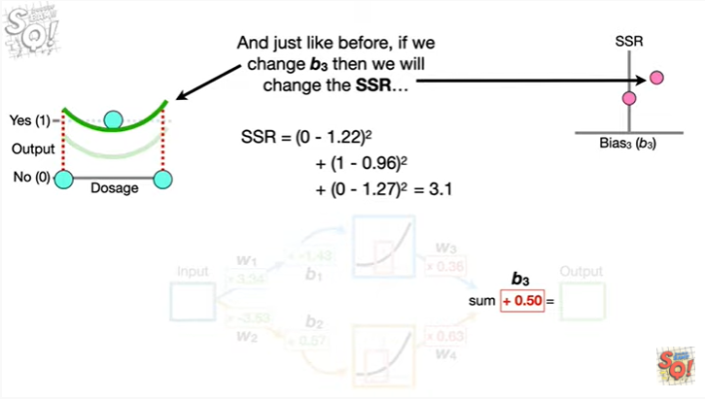

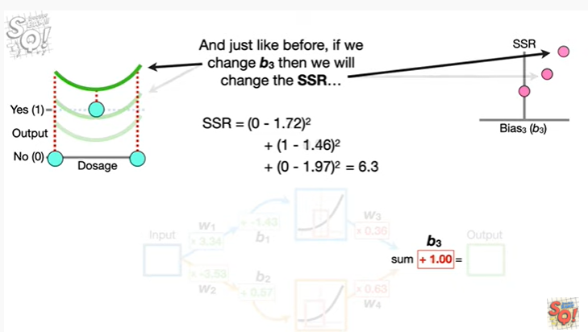

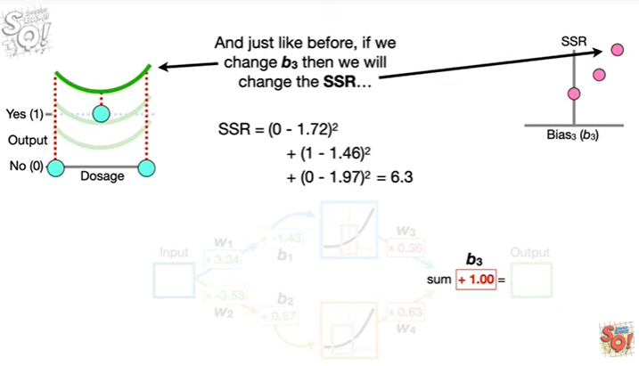

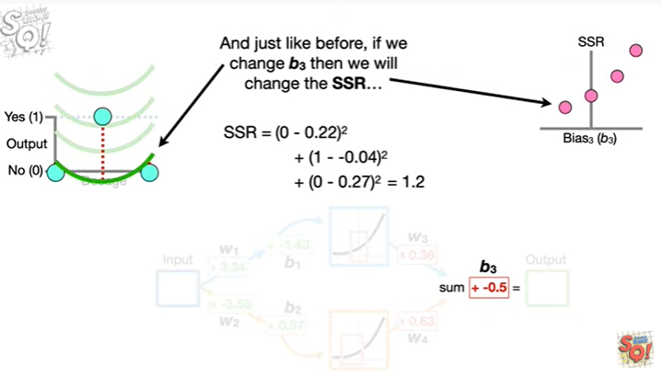

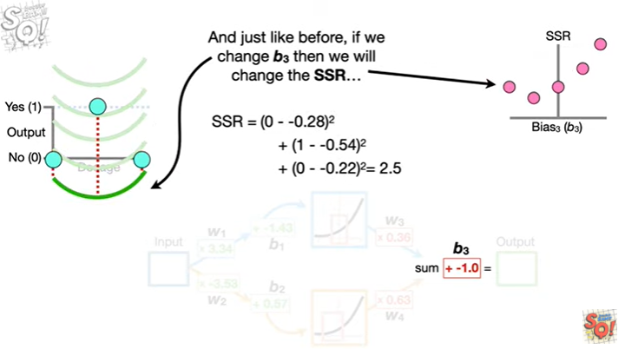

And just like before if we change b sub 3 then we will change the sum of the squared residuals

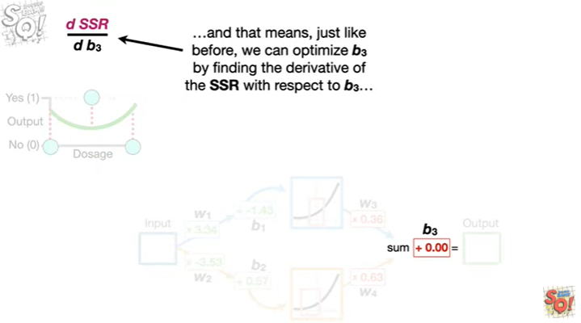

and that means just like before we can optimize b sub 3 by finding the derivative of the sum of the squared residuals with respect to b sub 3

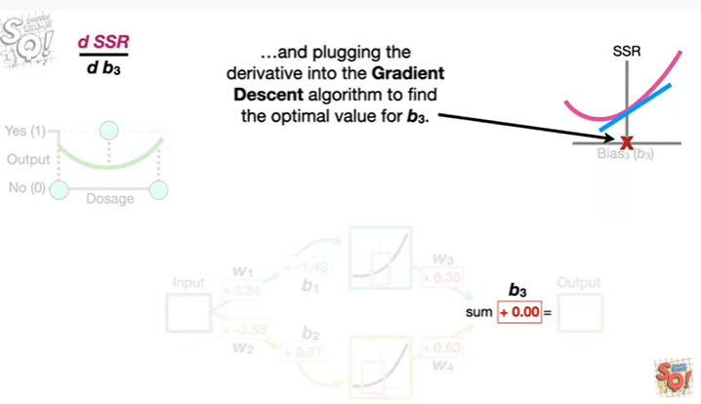

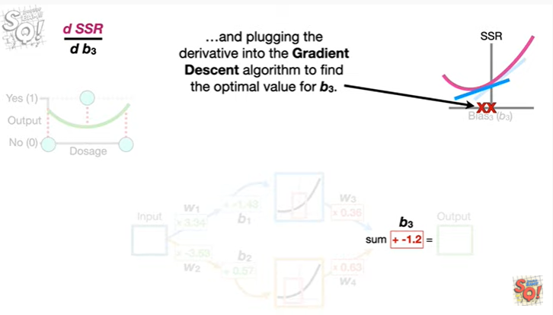

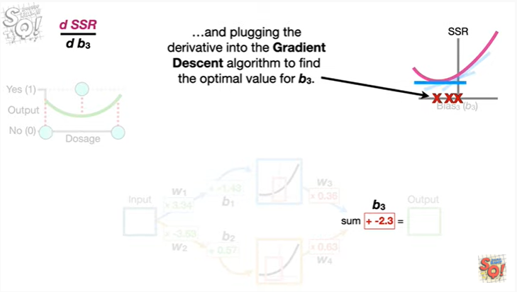

and plugging the derivative into the gradient descent algorithm to find the optimal value for b sub 3.

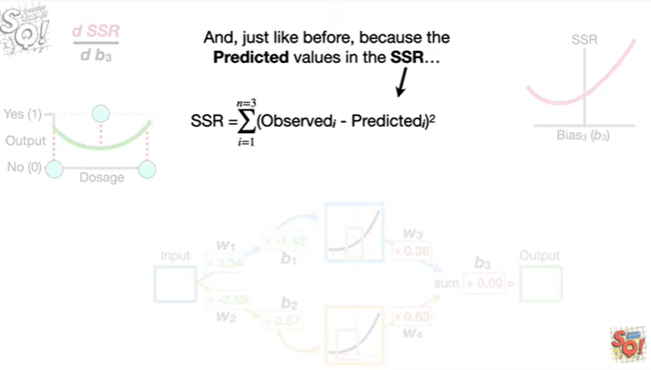

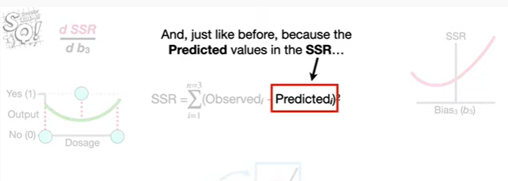

And, just like before, because the predicted values in the sum of the squared residuals

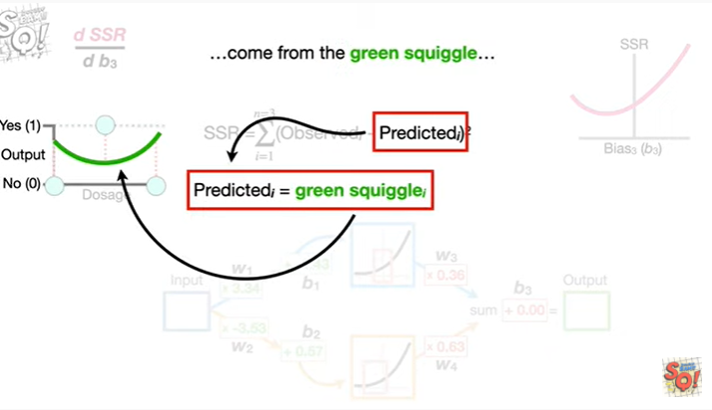

come from the green squiggle

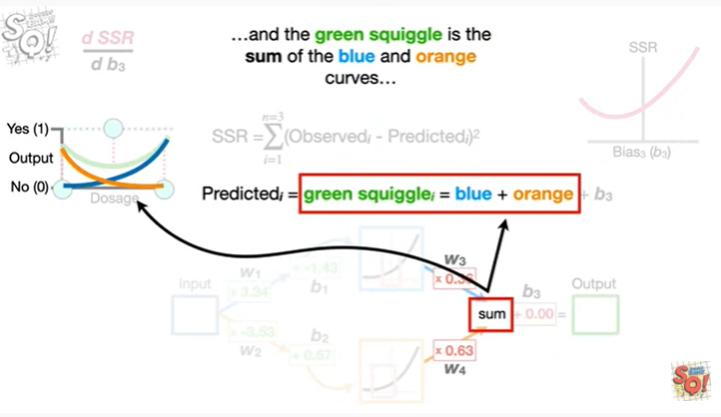

and the green squiggle is the sum of the blue and orange curves

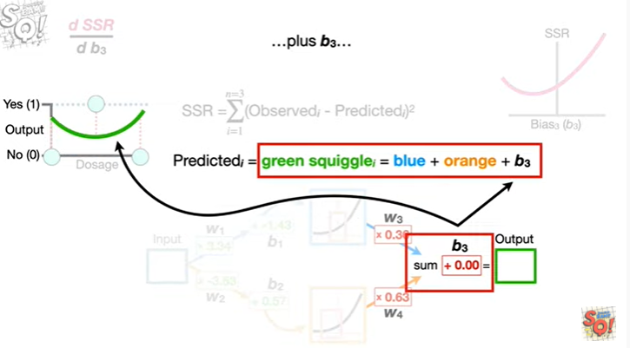

plus b sub 3

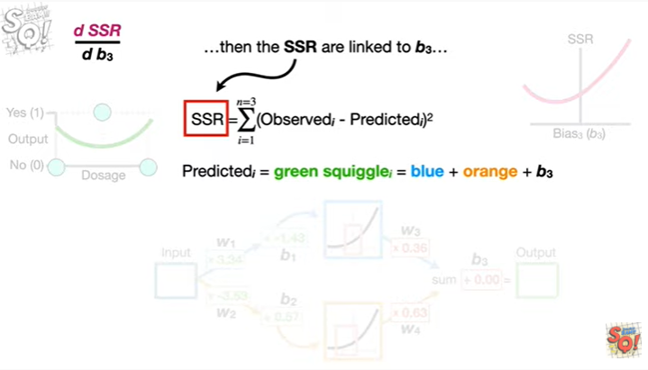

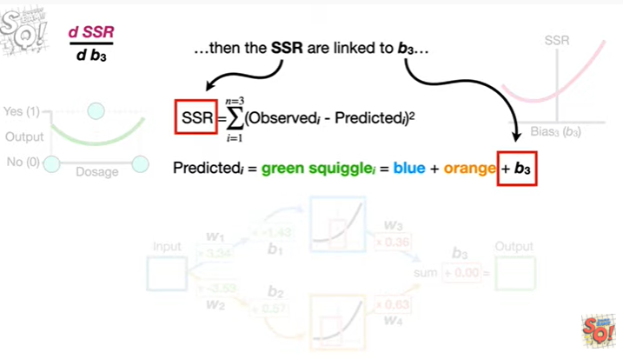

then the sum of the squared residuals are linked to b sub 3

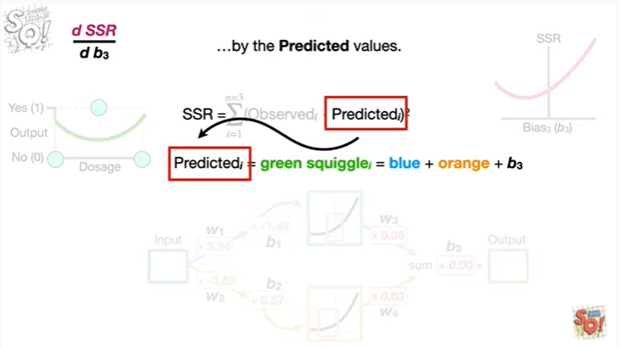

by the predicted values.

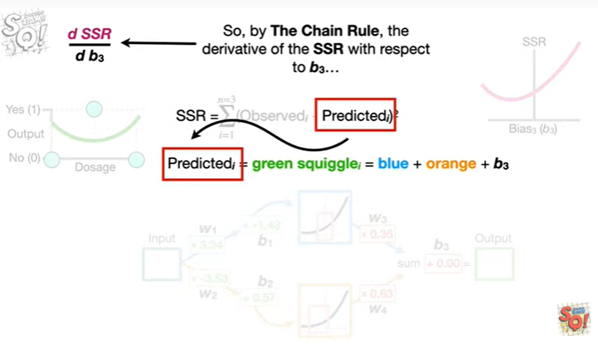

So by the chain rule the derivative of the sum of the squared residuals with respect to b sub 3

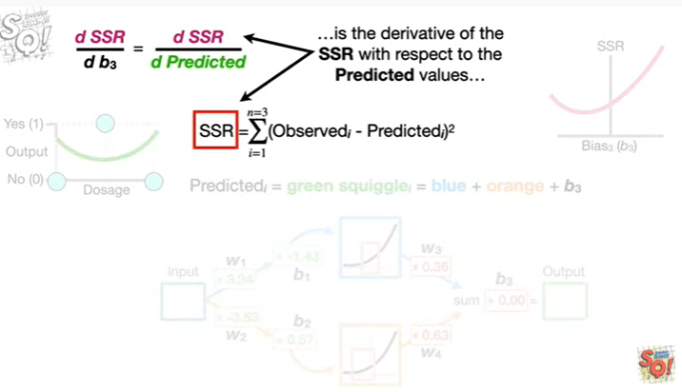

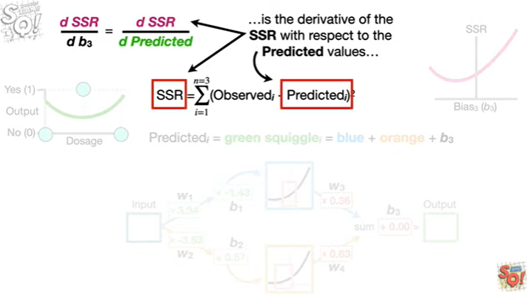

is the derivative of the sum of the squared residuals with respect to the predicted values

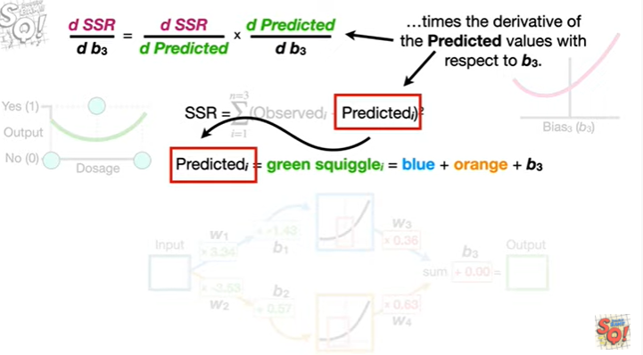

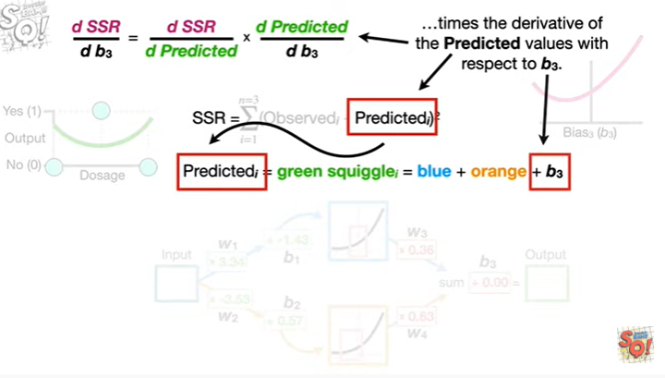

times the derivative of the predicted values with respect to b sub 3.

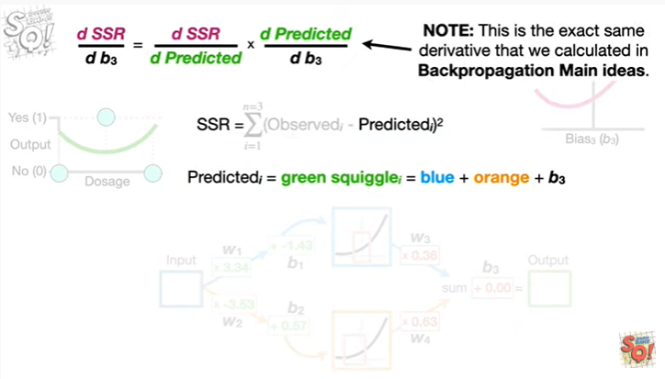

Note this is the exact same derivative that we calculated in back propagation main ideas.

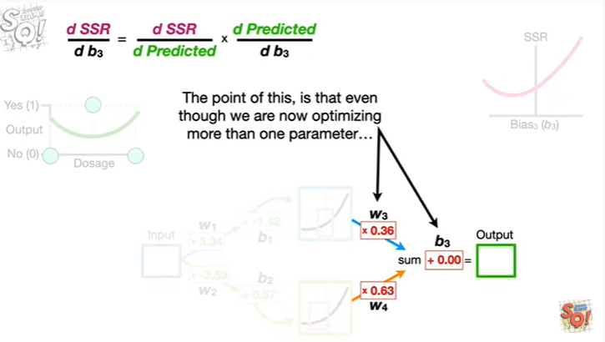

The point of this is that even though we are now optimizing more than one parameter

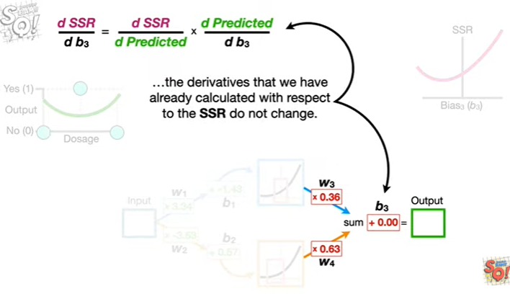

the derivatives that we have already calculated with respect to the sum of the squared residuals do not change.

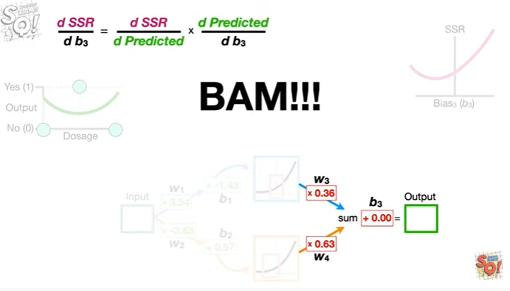

Bam !!!

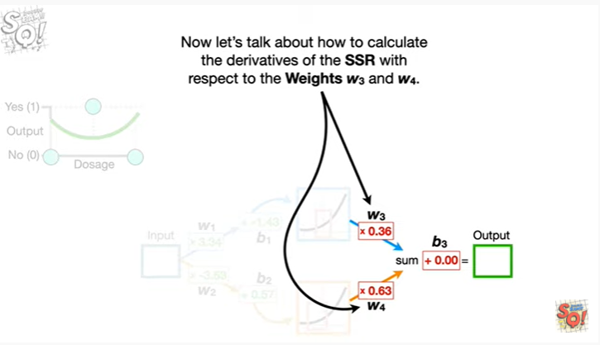

Now let's talk about how to calculate the derivatives of the sum of the squared residuals with respect to the weights w sub 3 and w sub 4.

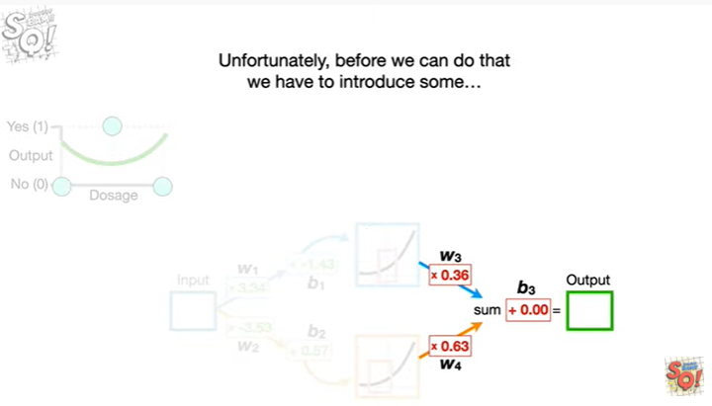

Unfortunately, before we can do that we have to introduce some



fancy notation !!!

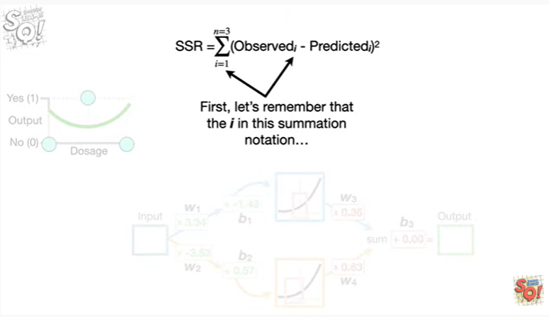

Firs,t let's remember that the i in this summation notation

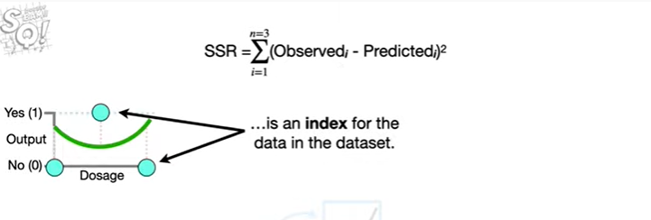

is an index for the data in the data set.

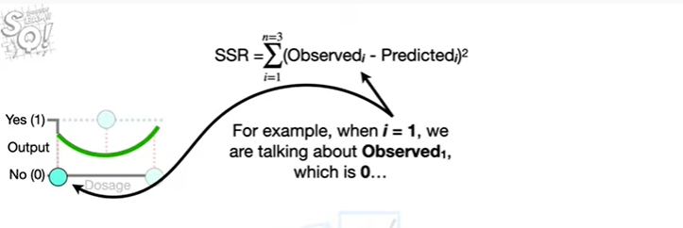

For example, when i equals one, we are talking about observed sub one which is zero

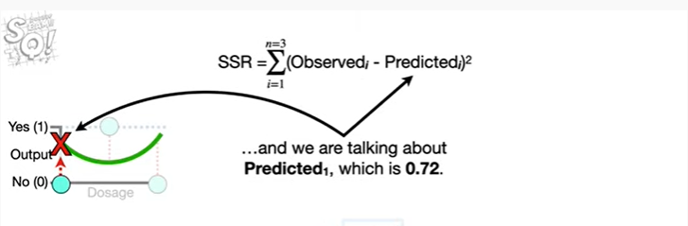

and we are talking about predicted sub 1 which is 0.72.

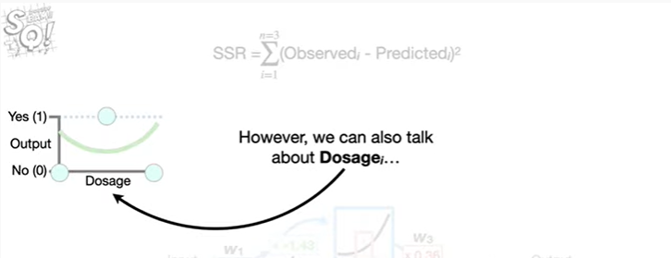

However, we can also talk about dosage sub i

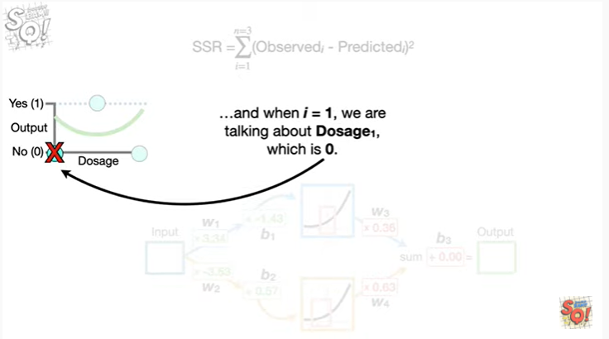

and when i equals 1, we are talking about dosage sub 1, which is 0.

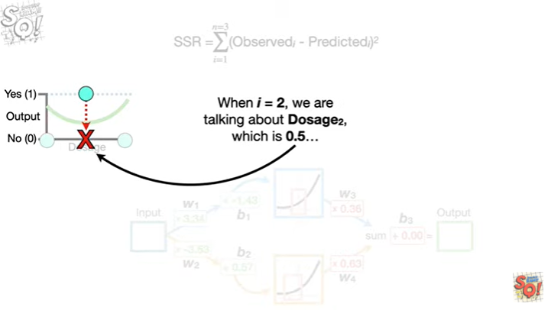

When i equals 2 we're talking about dosage sub 2 which is 0.5

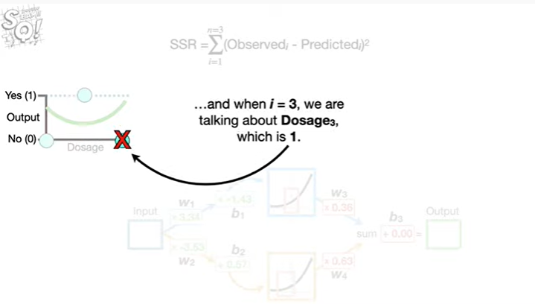

and when i equals 3 we're talking about dosage sub 3 which is 1.

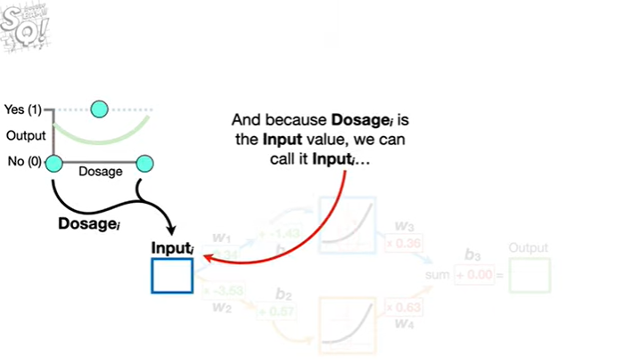

And because dosage sub i is the input value, we call it input sub i

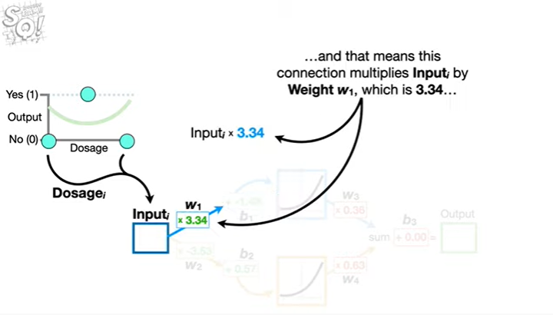

and that means this connection multiplies input sub i by weight w sub 1, which is 3.34

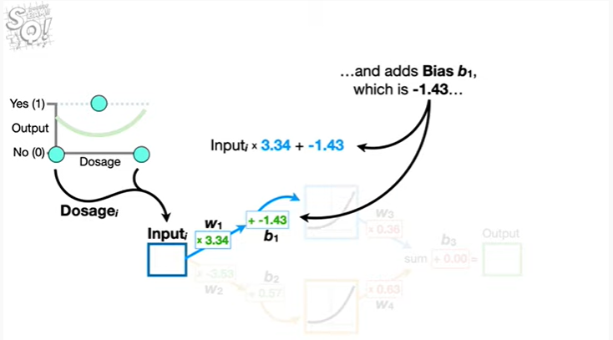

and it adds bias sub 1 which is negative 1.43

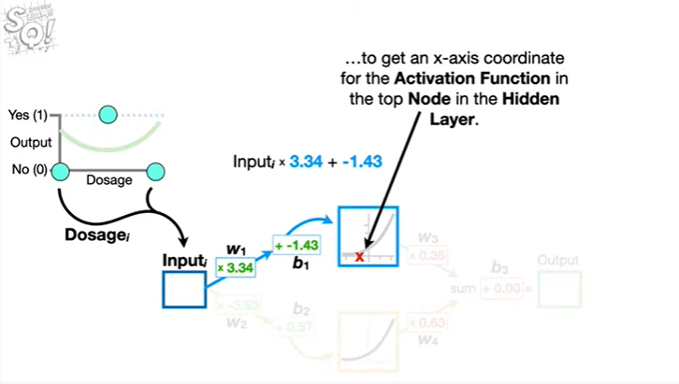

to get an x-axis coordinate for the activation function in the top node in the hidden layer.

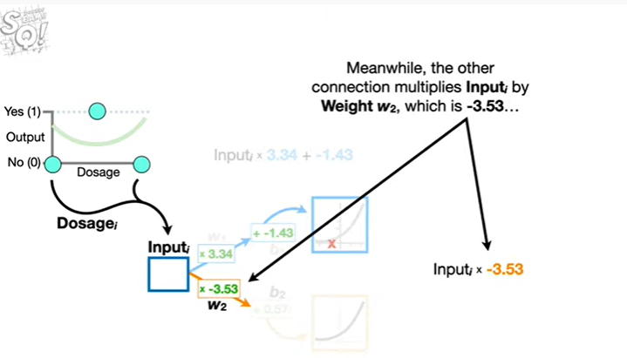

Meanwhile, the other connection multiplies input sub i by weight w sub 2, which is negative 3.53

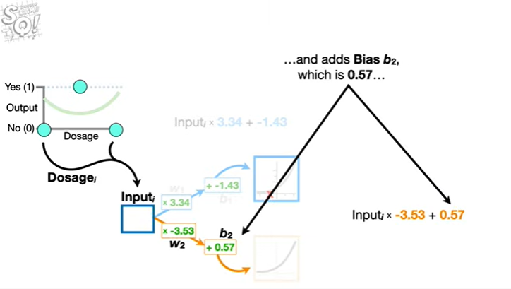and adds bias b sub 2 which is 0.57

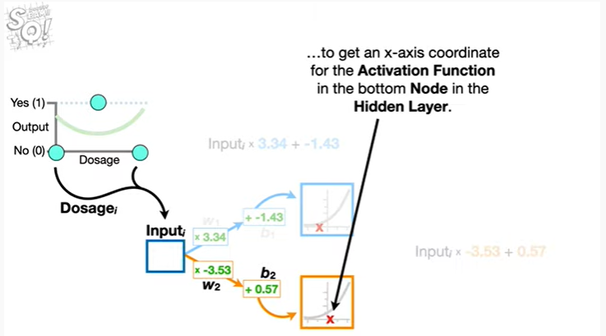

to get an x-axis coordinate for the activation function in the bottom node in the hidden layer.

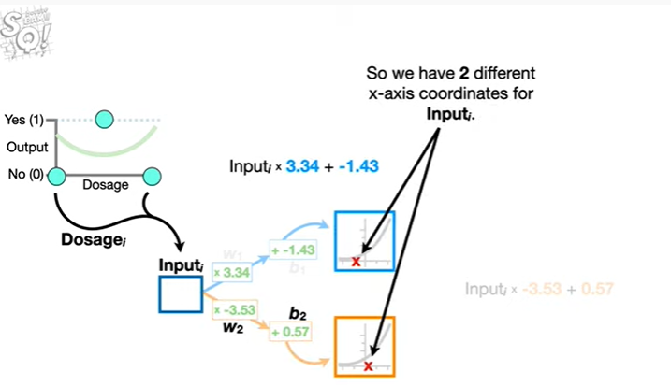

So we have two different x-axis coordinates for input sub i.

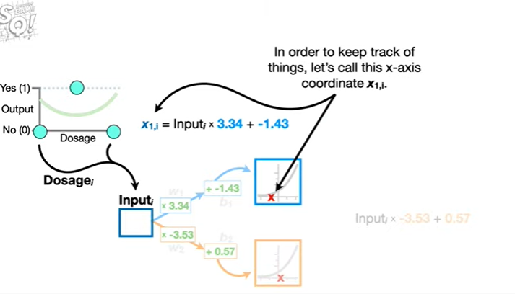

In order to keep track of things, let's call this x axis coordinate x sub 1 comma i.

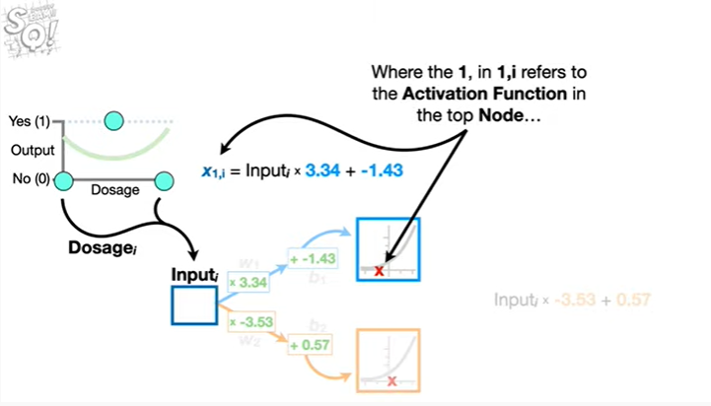

Where the one, in one comma i, refers to the activation function in the top node

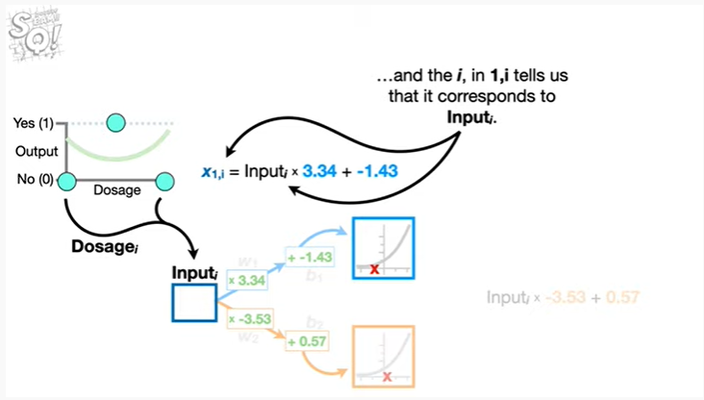

and the i, in one comma i, tells us that it corresponds to input sub i.

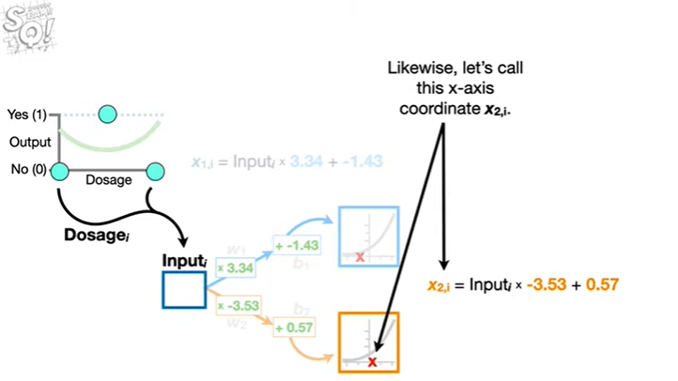

Likewise, let's call this x axis coordinate x sub 2 comma i.

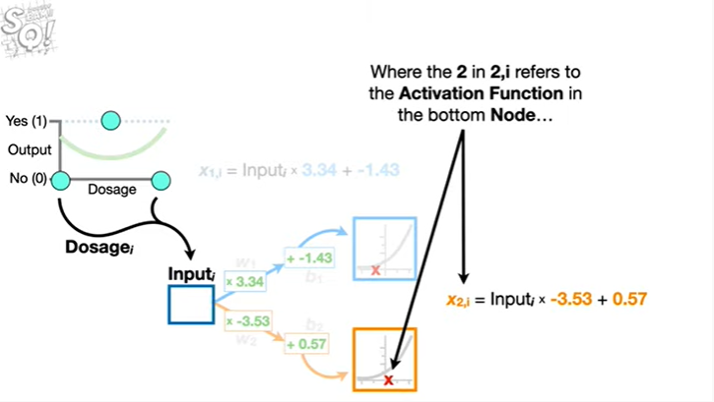

Where the 2, in 2 comma i, refers to the activation function in the bottom node

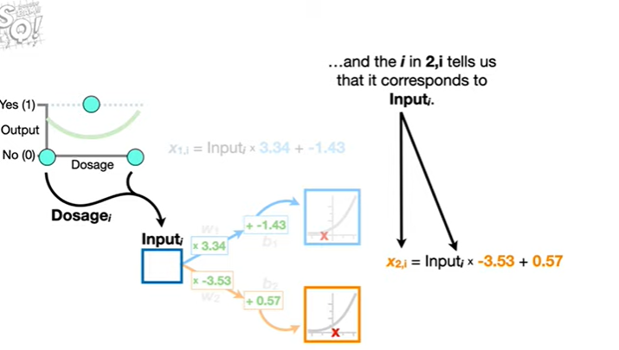

and the i in 2 comma i tells us that it corresponds to input sub i.

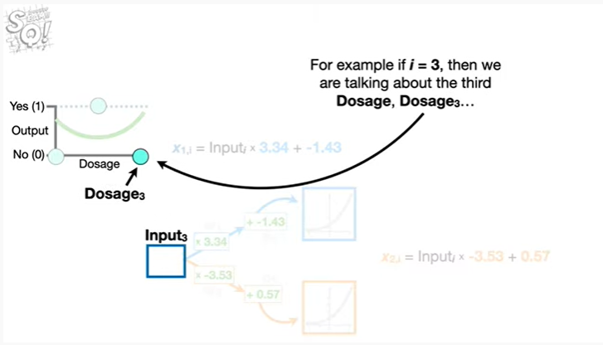

For example if i equals 3, then we're talking about the third dosage, dosage sub 3

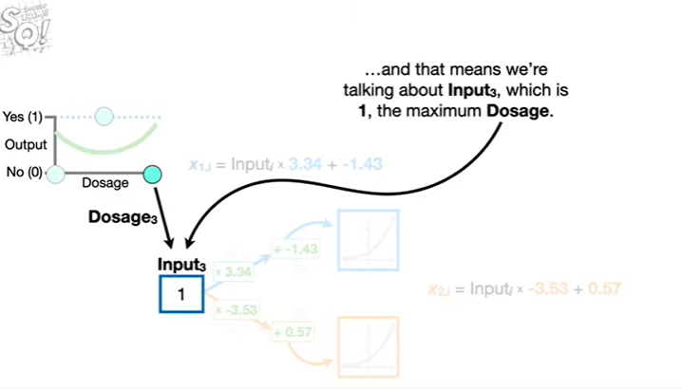

and that means we're talking about input sub 3, which is 1, the maximum dosage.

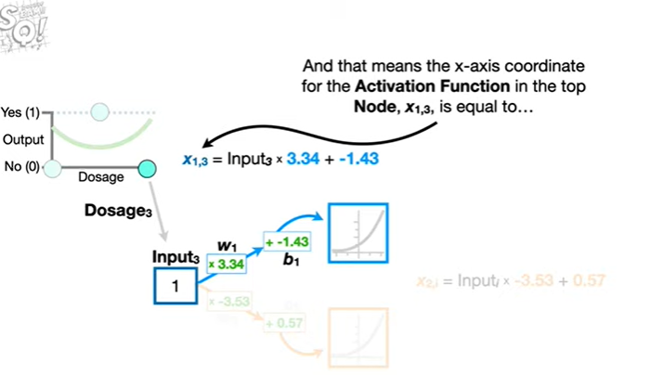

And that means the x-axis coordinate for the activation function in the top node x sub 1 comma 3, is equal to

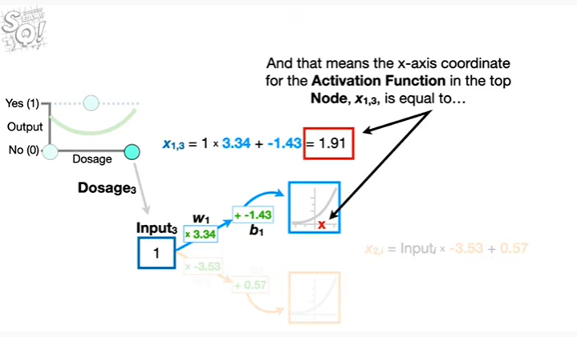

1.91

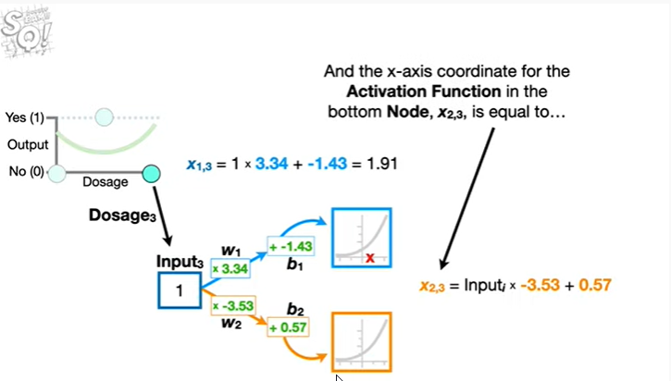

And the x-axis coordinate for the activation function in the bottom node x sub 2 comma 3, is equal to

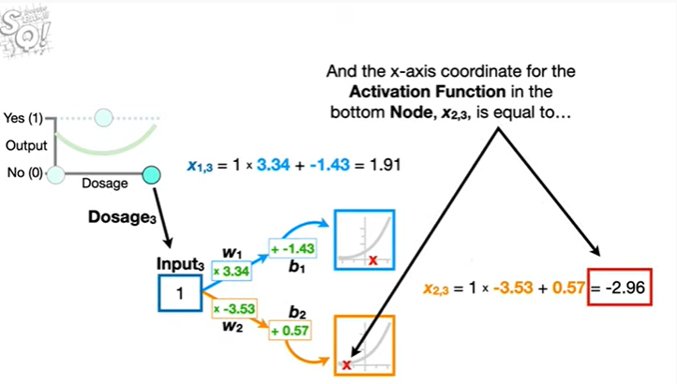

negative 2.96.

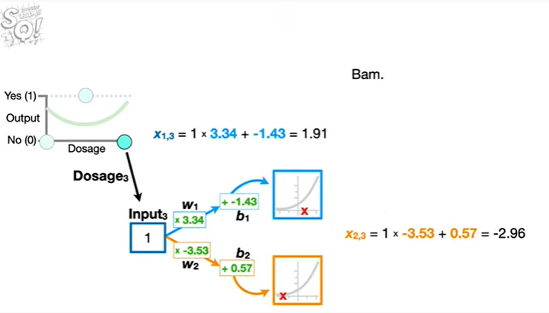

Bam.

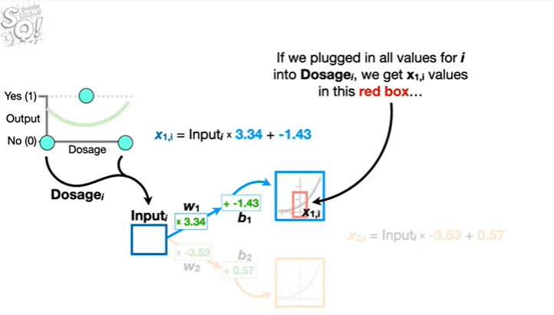

If we plugged in all values for i into dosage sub i, we get x sub 1 comma i values in this red box

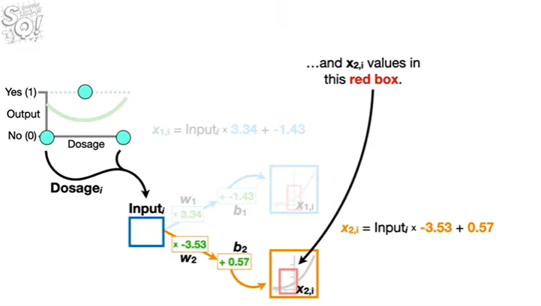

and x sub 2 comma i values in this red box.

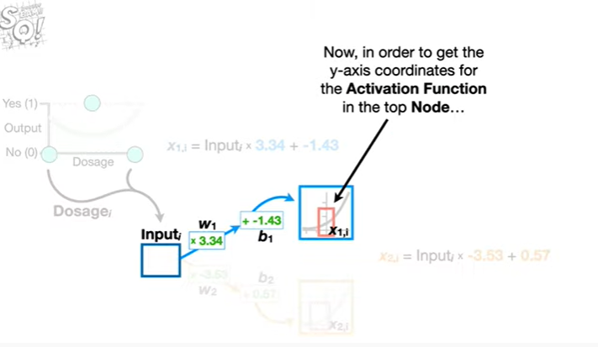

Now, in order to get the y axis coordinates for the activation function in the top node

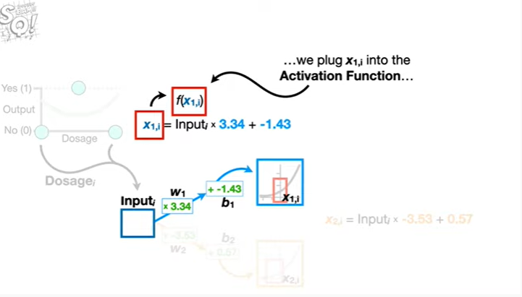

we plug x sub 1 comma i into the activation function

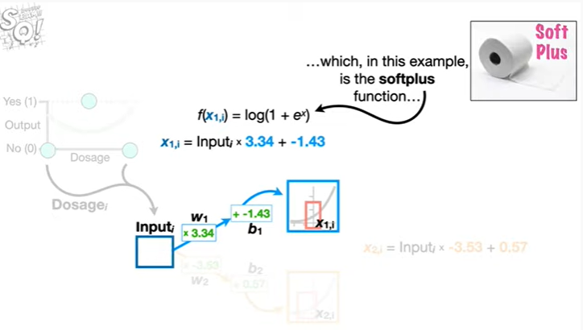

which in this example, is the soft plus function